HURST-DAVIES.-On the 25th January, at Col-lege Park, by Revs. J. E. Creswell and J. C.
Fix this text
Kirby, Reginald Leslie, youngest son of Mr. andMrs. H. L Hurst, Dutton-terrace, Medindie, toLily Malcolm (late Sister A.I.F.), only child ofMrs. Davies, Albert-street, Payneham, and thelate T. E. Davies, Semaphore.
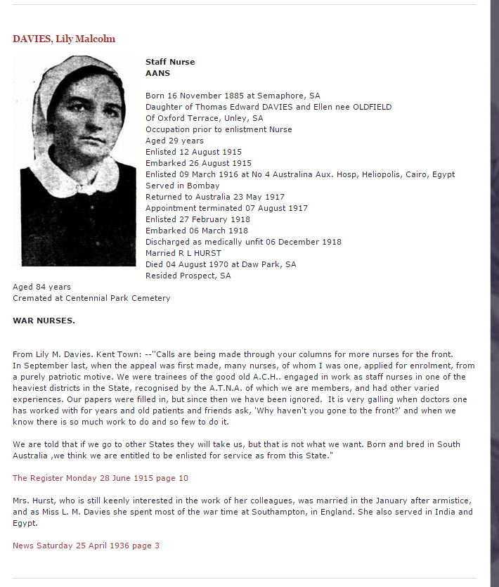

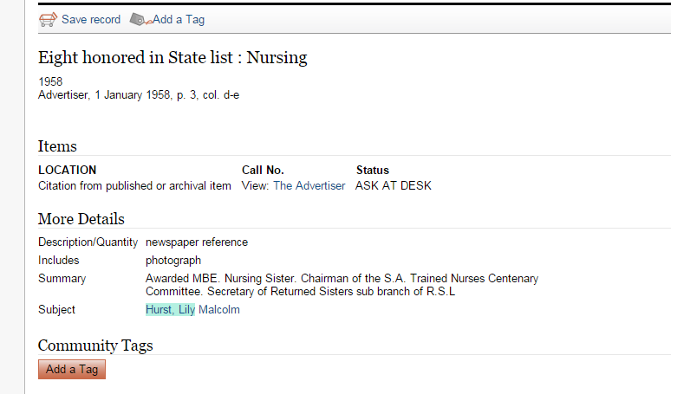
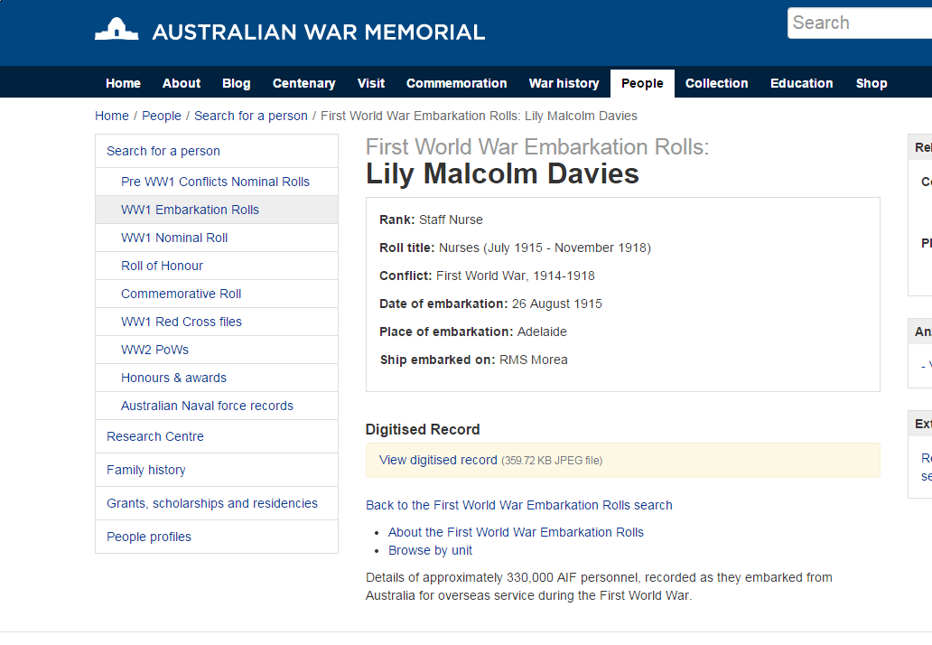
http://www.awm.gov.au/people/rolls/R2052160/

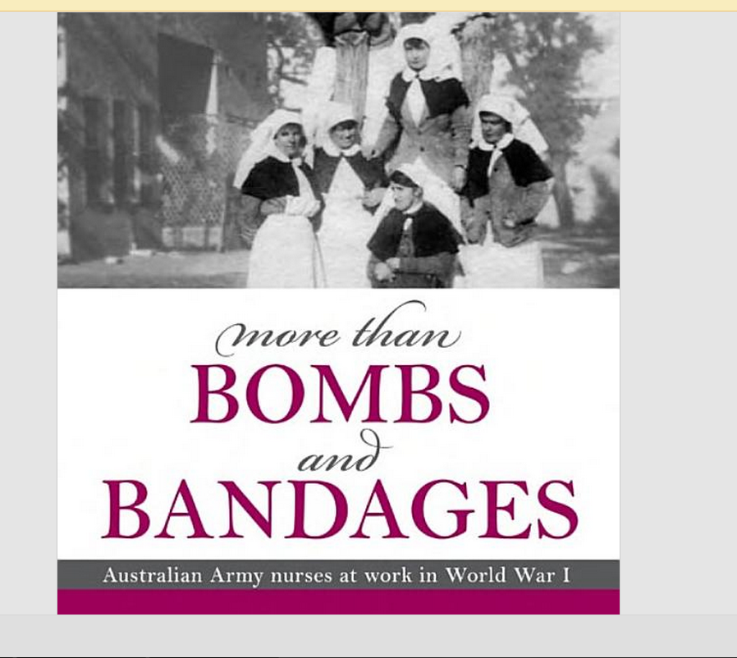
https://books.google.com.au/books?id=8cOnFH7bzL8C&pg=PT276&lpg=PT276&dq=lily+malcolm+davies&source=bl&ots=znuIpcYBaa&sig=nQ9FzElK11MzJfpjEDC_dh41DII&hl=en&sa=X&ei=tofAVJntO8_p8AWeoYG4CA&ved=0CCwQ6AEwAw#v=onepage&q=lily%20malcolm%20davies&f=false

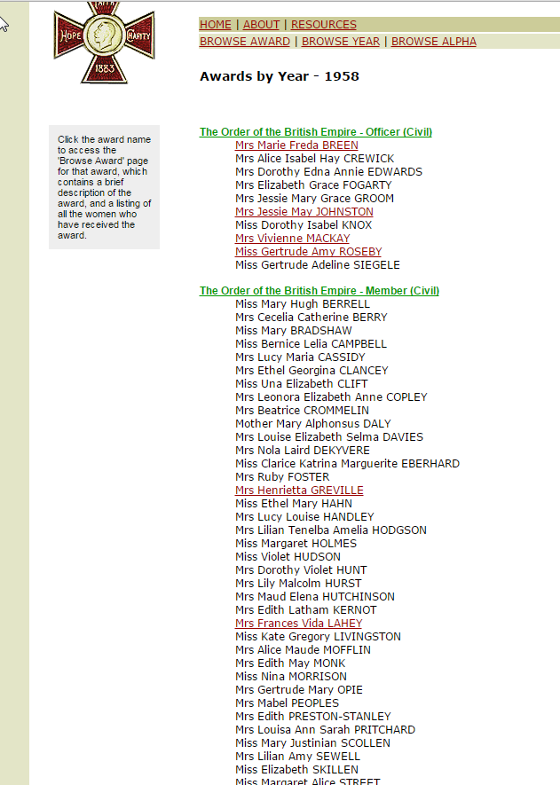
http://www.womenaustralia.info/exhib/honours/1958.html

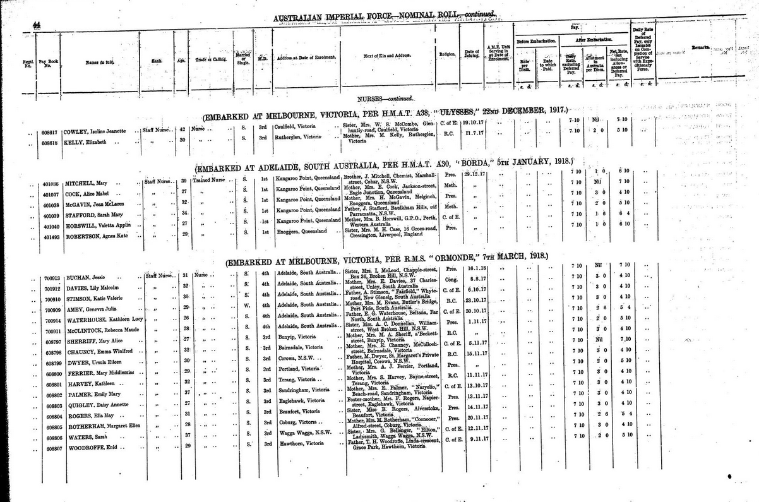
http://static.awm.gov.au/images/collection/items/ACCNUM_LARGE/RCDIG1067536/RCDIG1067536--475-.JPG

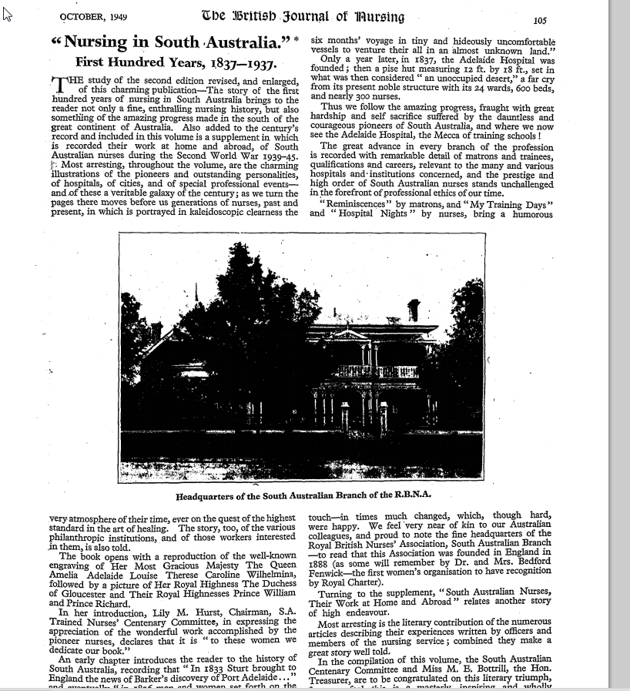
http://rcnarchive.rcn.org.uk/data/VOLUME097-1949/page105-volume97-october1949.pdf

